EXPT NO: 1 | BUILDING AND TRAINING A SIMPLE ARTIFICIAL NEURAL NETWORK (ANN) FOR REGRESSION AND CLASSIFICATION
DATE: 20-07-2026

PRE-LAB QUESTIONS (PROVIDE BRIEF ANSWERS TO THE FOLLOWING QUESTIONS)

- What is an Artificial Neural Network (ANN)?
An Artificial Neural Network (ANN) is a machine learning model inspired by the human brain. It consists of interconnected neurons (nodes) that learn patterns from data to make predictions or classifications.
- What are the functions of the input, hidden, and output layers in an ANN?
Input Layer: Receives the input data (features) and passes it to the network.
Hidden Layer: Processes the input data, learns patterns, and extracts useful features.
Output Layer: Produces the final prediction or classification result.

- Why is feature scaling important before training an ANN?
Feature scaling ensures that all input features are on a similar scale. This helps the ANN learn faster, improves accuracy, and prevents features with larger values from dominating the training process.

- Differentiate between regression and classification problems with examples.

Regression | Classification
Predicts continuous numerical values. | Predicts categories or classes.
Output is a number. | Output is a label or class.
Example: Predicting house prices or student marks. | Example: Email spam detection or disease prediction (Yes/No).

- What is the role of the activation function in a neural network?
An activation function introduces non-linearity into the neural network, allowing it to learn complex patterns. It helps the network decide whether a neuron should be activated and pass information to the next layer.

AIM
To understand the implementation of Artificial Neural Networks (ANN) using TensorFlow and evaluate their performance on regression and classification problems.

SOFTWARE REQUIREMENTS
- Python 3.x
- Google Colab / Jupyter Notebook
- TensorFlow 2.x
- NumPy
- Pandas
- Matplotlib
- Scikit-learn

LEARNING OBJECTIVES
After completing this experiment, students will be able to:
- Understand the architecture of an Artificial Neural Network.
- Build an ANN for regression problems.
- Build an ANN for classification problems.
- Train and evaluate neural network models.
- Compare different evaluation metrics used for regression and classification.

THEORY
An Artificial Neural Network (ANN) is a machine learning model inspired by the human brain. It consists of interconnected neurons organized into layers.
A simple ANN contains:
- Input Layer
- Hidden Layer(s)
- Output Layer
During training, the ANN learns by updating weights using Backpropagation and an optimization algorithm such as Adam Optimizer.

PART A – ANN FOR REGRESSION
DATASET: California Housing Dataset
SOURCE: Scikit-learn
DESCRIPTION
- Samples: 20,640
- Features: 8
- Target: Median House Value

FEATURES
Feature | Description
MedInc | Median Income
HouseAge | House Age
AveRooms | Average Rooms
AveBedrms | Average Bedrooms
Population | Population
AveOccup | Average Occupancy
Latitude | Latitude
Longitude | Longitude

ALGORITHM
- Import libraries.
- Load California Housing dataset.
- Split into training and testing sets.
- Standardize the features.
- Build ANN model.
- Compile the model.
- Train the model.
- Predict house prices.
- Evaluate using:
  - MSE
  - MAE
  - RMSE
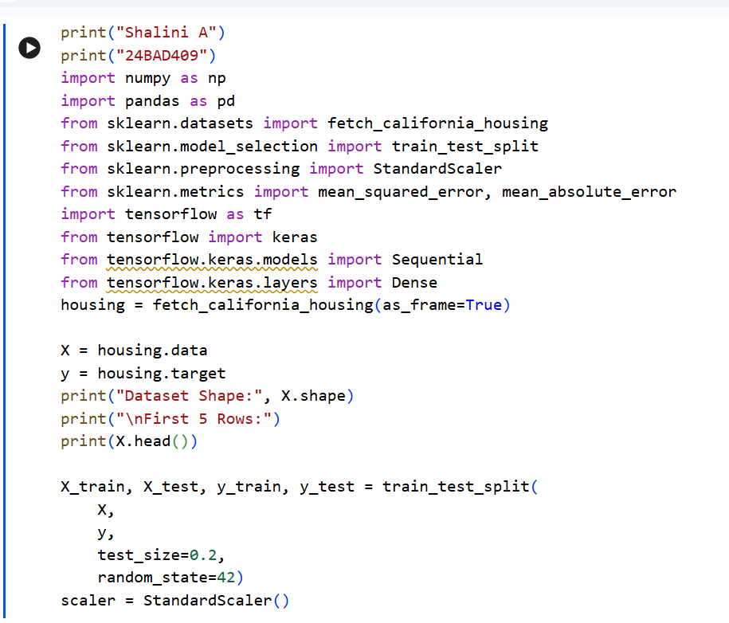
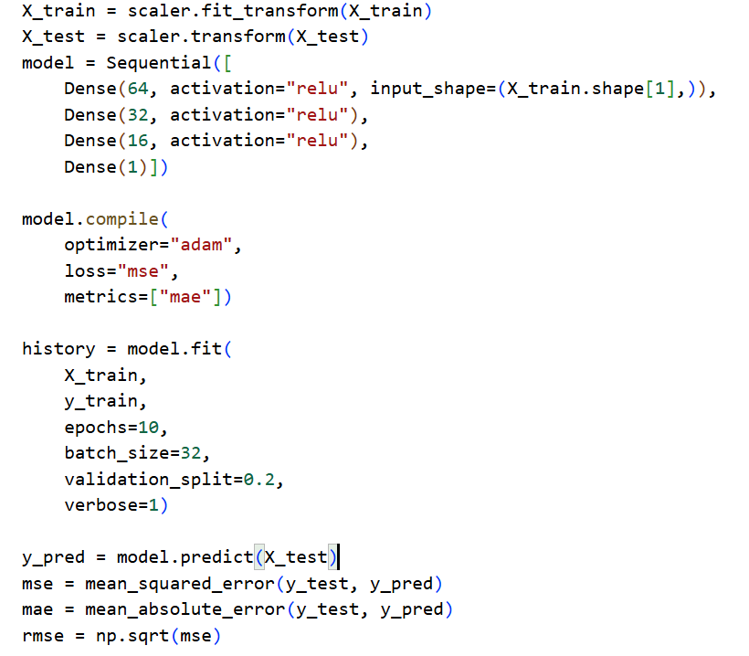
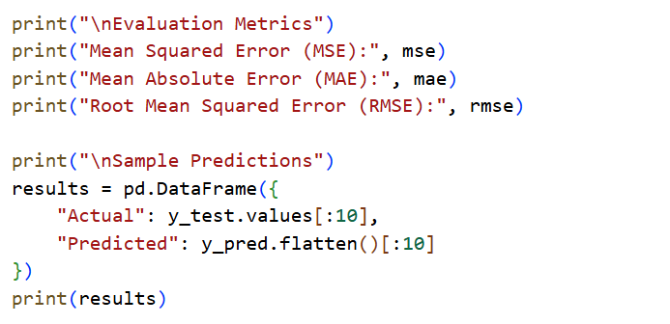

Output:
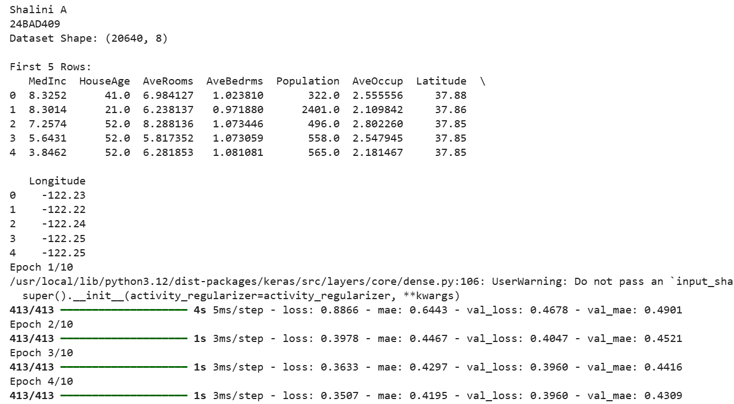
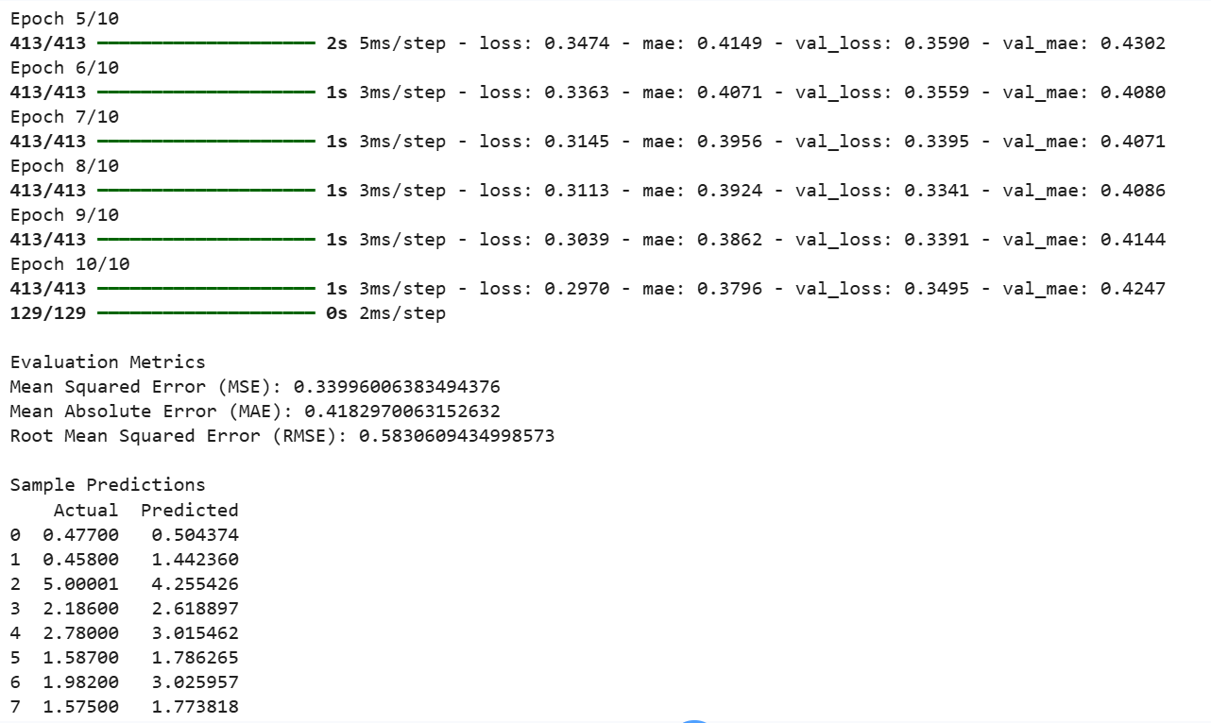

PART B – ANN FOR CLASSIFICATION
DATASET: Breast Cancer Wisconsin Dataset
SOURCE: Scikit-learn
DESCRIPTION
- Samples: 569
- Features: 30
- Classes:
  - Malignant
  - Benign

ALGORITHM
- Import libraries.
- Load Breast Cancer dataset.
- Split dataset.
- Standardize features.
- Design ANN.
- Compile model.
- Train model.
- Predict labels.
- Evaluate:
  - Accuracy
  - Precision
  - Recall
  - F1-score
  - Confusion Matrix

CODE:
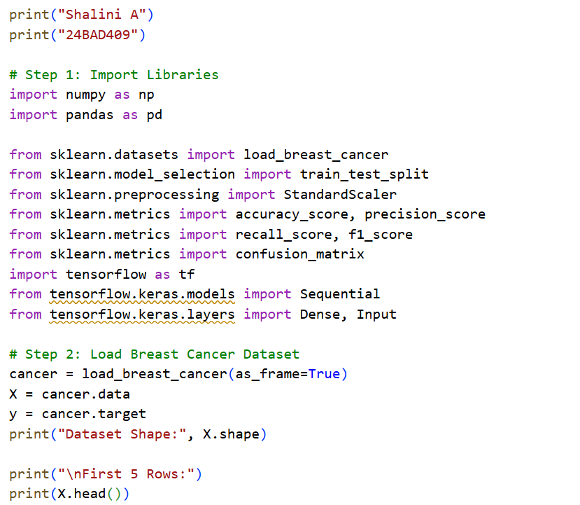
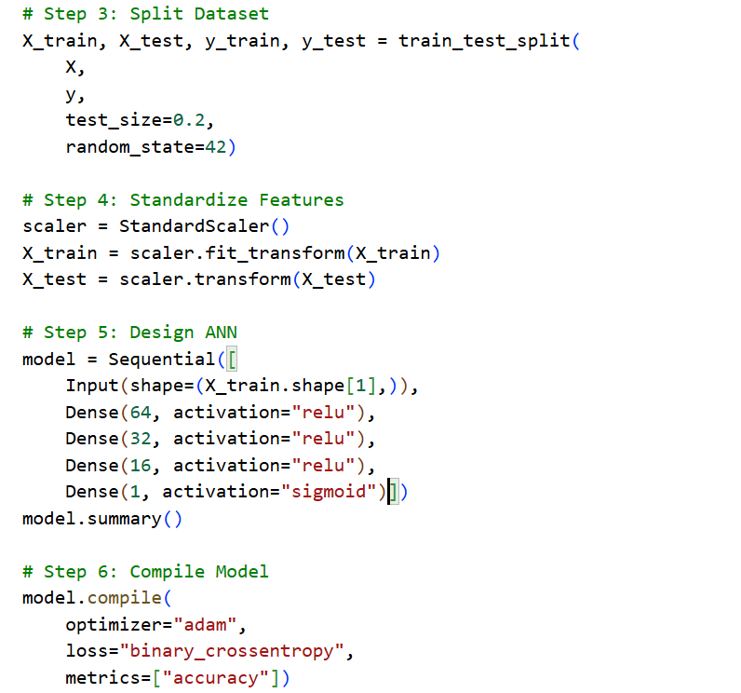
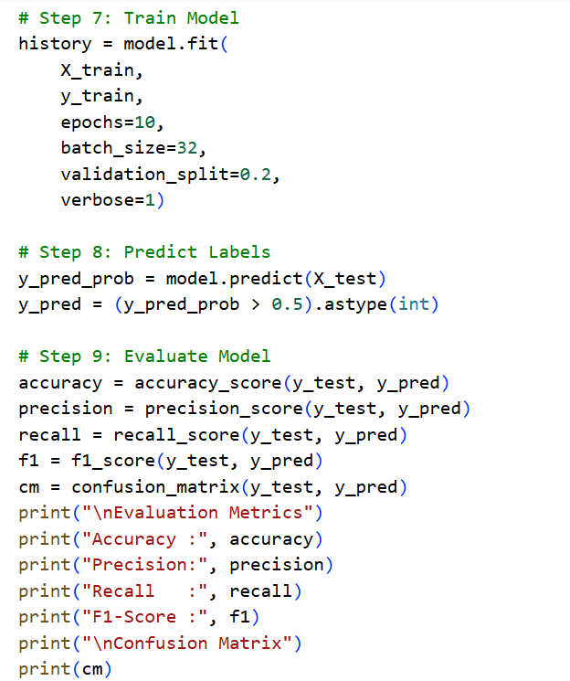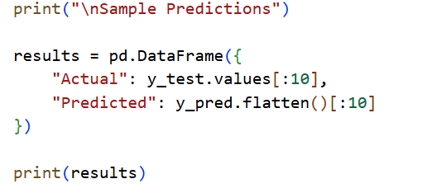
OUTPUT:
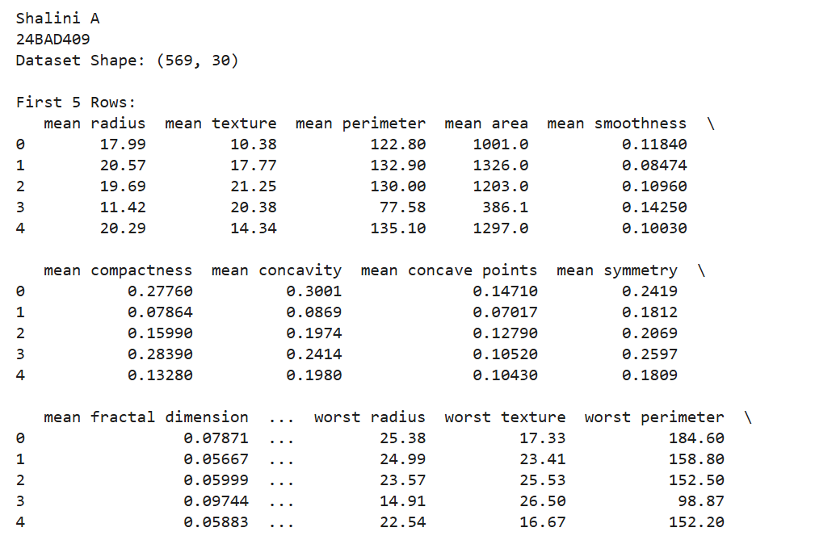
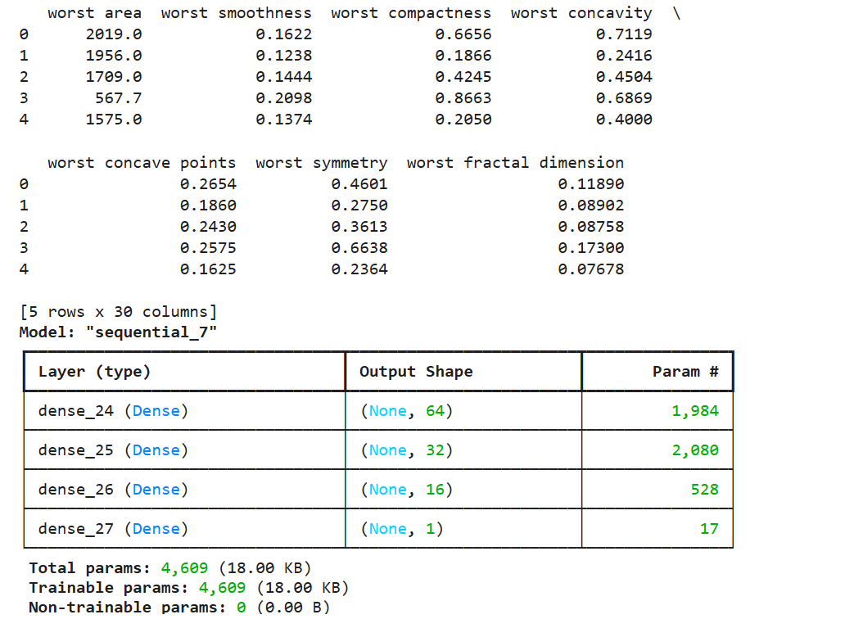

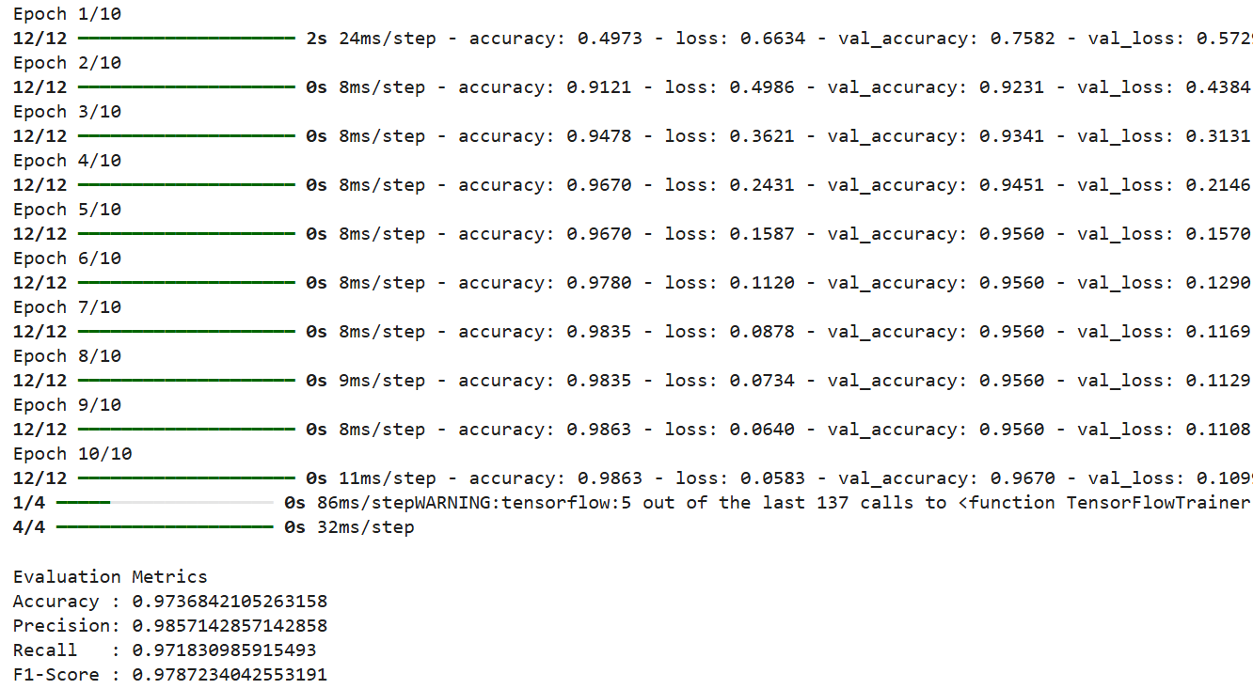
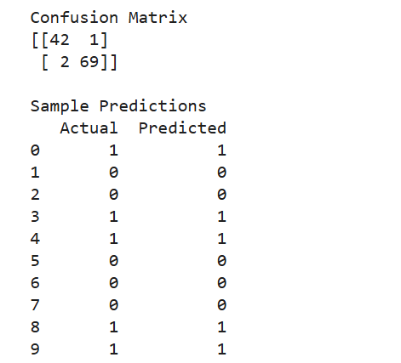

POST-LAB QUESTIONS (PROVIDE BRIEF ANSWERS TO THE FOLLOWING QUESTIONS)

- Why is the Adam optimizer commonly used in ANN training?
The Adam (Adaptive Moment Estimation) optimizer is commonly used because it updates the model weights efficiently, converges faster, and requires less tuning. It combines the advantages of Momentum and RMSProp optimizers.

- Compare Mean Squared Error (MSE) and Mean Absolute Error (MAE). Which metric is more sensitive to outliers?

MSE | MAE
Measures the average of squared errors. | Measures the average of absolute errors.
Gives more weight to large errors. | Treats all errors equally.
More sensitive to outliers. | Less sensitive to outliers.

- Why is the sigmoid activation function used in binary classification?
The sigmoid activation function converts the output into a value between 0 and 1, representing the probability of belonging to a class. It is suitable for binary classification problems such as Malignant or Benign.
- How does increasing the number of hidden layers affect the performance of an ANN?
Increasing the number of hidden layers helps the ANN learn more complex patterns and improve accuracy. However, too many hidden layers can increase training time and may lead to overfitting if not properly managed.

- Compare the evaluation metrics used for regression and classification tasks. Why are different metrics required for these problems?

Regression | Classification
MSE, MAE, RMSE | Accuracy, Precision, Recall, F1-score, Confusion Matrix
Predicts continuous numerical values. | Predicts categories or classes.

ASSESSMENT
Description | Max Marks | Marks Awarded
Pre Lab Exercise | 5
In Lab Exercise | 10
Post Lab Exercise | 5
Viva | 10
Total | 30
Faculty Signature

